Retail Sales Insights with SQL + Python

Project Title: Retail Sales Analysis Project
Student Name: Nirmala Rathod

Objective
The purpose of this project is to analyze retail sales data to identify top-selling products, customer behavior, and monthly sales trends.

Database Schema
Tables:
- Products
  - product_id (INTEGER, PRIMARY KEY)
  - name (TEXT)
  - category (TEXT)
  - price (REAL)
- Customers
  - customer_id (INTEGER, PRIMARY KEY)
  - first_name (TEXT)
  - last_name (TEXT)
  - age (INTEGER)
  - city (TEXT)
- Sales
  - sale_id (INTEGER, PRIMARY KEY)
  - sale_date (TEXT)
  - product_id (INTEGER, FK → Products)
  - customer_id (INTEGER, FK → Customers)
  - quantity (INTEGER)
  - total_price (REAL)
- 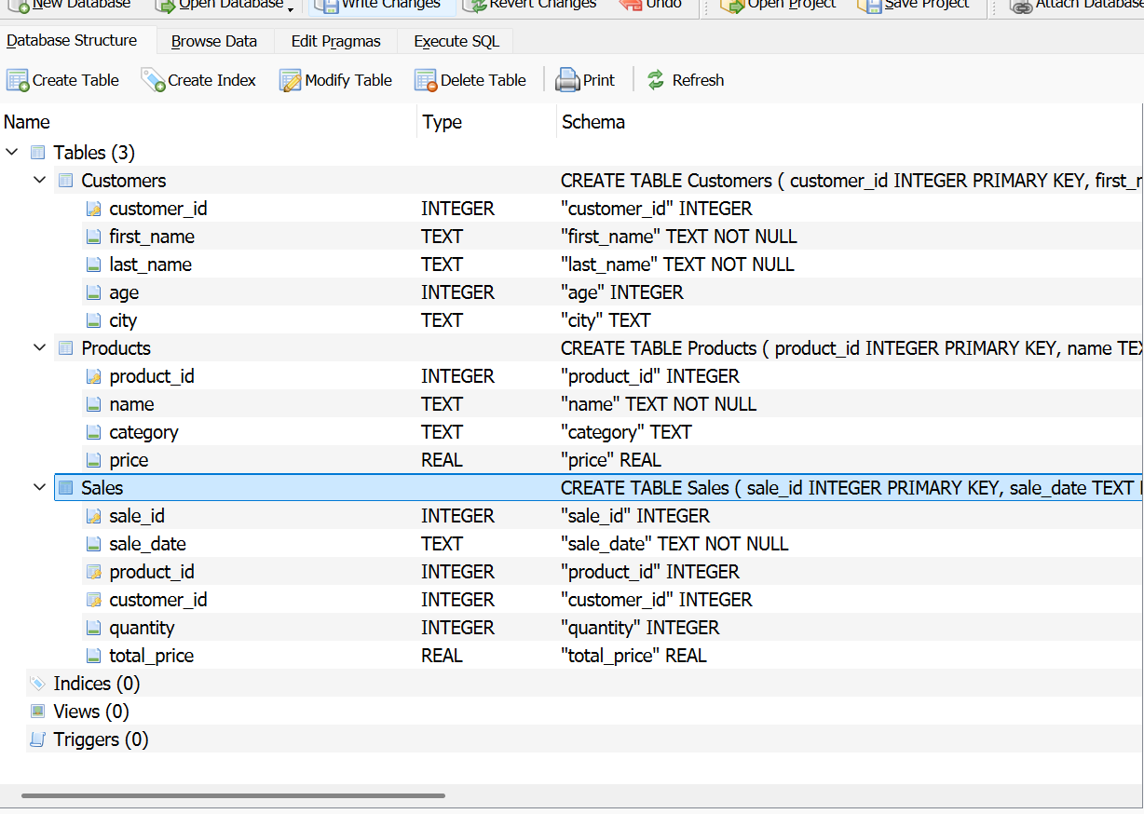

SQL Queries and Results
Best-selling product
Total sales per category:
Average purchase per customer:
Monthly sales trend:

Visualizations

SQL Queries and Results

Best-selling product

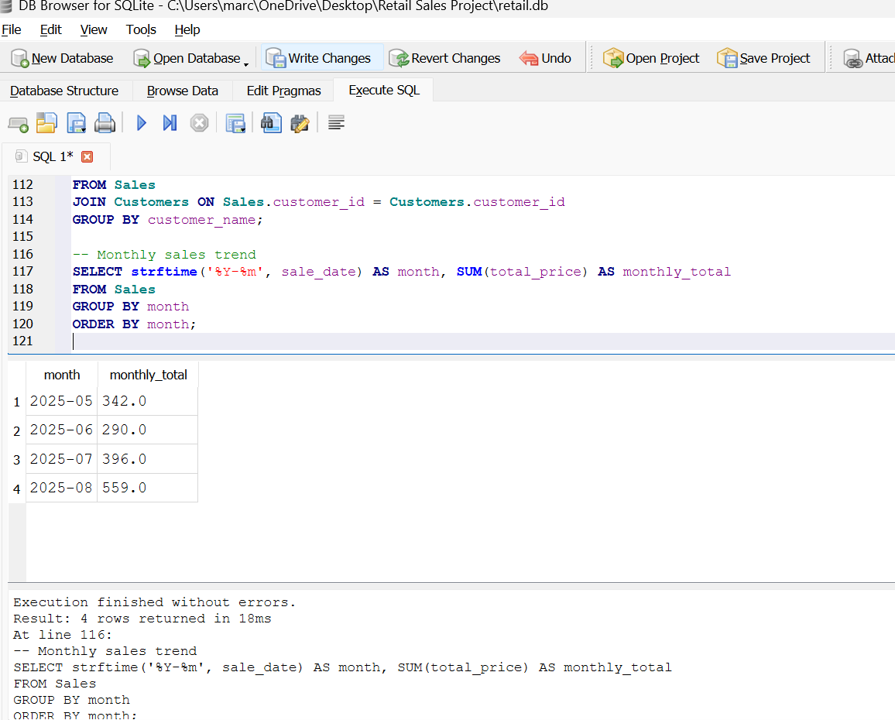

1. Total Sales by Category
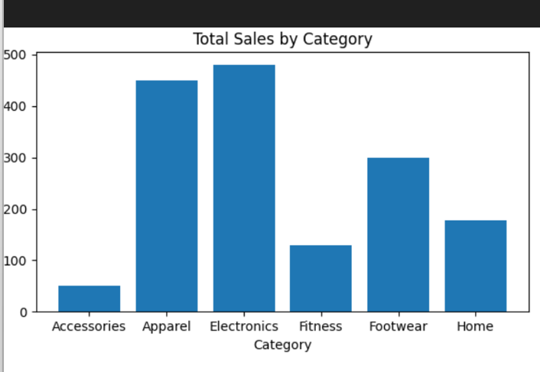
Observation: Electronics and Apparel are the top-selling categories. Accessories have the lowest sales.
2. Average Purchase per Customer
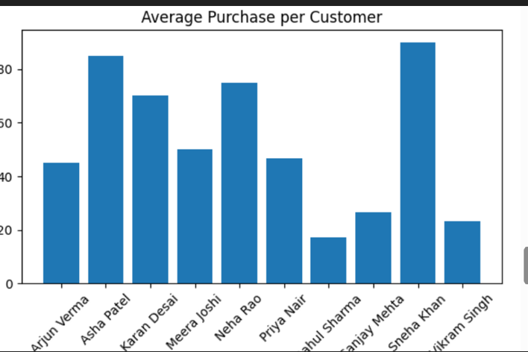
Observation: Sneha Khan and Asha Patel are the highest spenders. Vikram Singh and Rahul Sharma spend the least.
3. Monthly Sales Trend
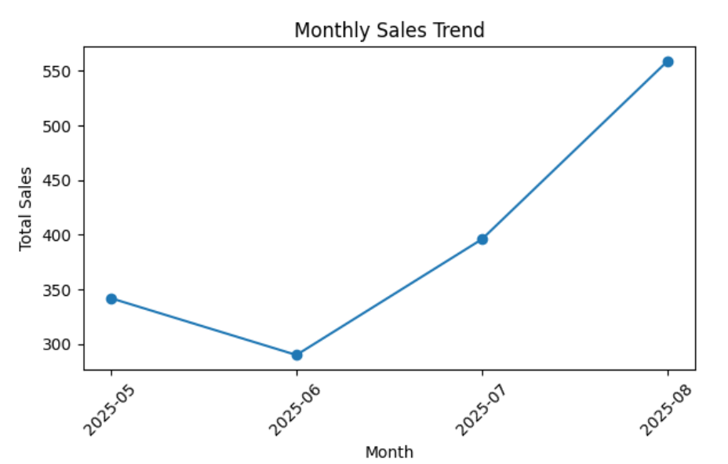
Observation: Sales steadily increased from May to August, with August being the highest month.

Business Recommendations
- Focus marketing and stock on top categories (Electronics and Apparel).
- Offer loyalty programs for high-value customers.
- Plan promotions during months with lower sales (e.g., June).
- Consider strategies to boost low-selling categories
Mentor/Instructor: moushreeta

